AIRLINES DATA

Perform Clustering for the crime data and identify the number of clusters formed and draw inferences.

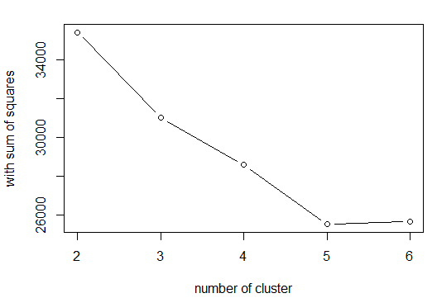

|  |  |  |  |
| --- | --- | --- | --- |
| K-VALUE | TWSS | TBSS | TSS |
| k=3 | 118 | 78 | 196 |
| K=4 | 73.1 | 123 | 196 |
| K=5 | 50.3 | 146 | 196 |
| K=6 | 42.9 | 153 | 196 |

|  |
| --- |
| INFERENCE:  when k=4 TOTAL WITHIN SUM OF SQUARE IS LESS AND TOTAL BETWEEN SUM OF SQUARE IS MORE..HENCE K=4 WOULD BE OPTIMIAL K VALUE |